**Танк. Рис.1**

|  |  |  |  |  |
| --- | --- | --- | --- | --- |
|  |  |  |  | https://aababy.ru/sites/default/files/styles/images203_175/public/soldat_s_flagom.png?itok=YS5234Dq |
| http://radarek.github.io/presentations/Crystal%20-%20better%20Ruby%3F%20-%20KRUG%2018.12.2016/images/bomb.png |  | https://st2.depositphotos.com/1011127/11410/v/950/depositphotos_114106272-stock-illustration-steam-train-in-tunnel.jpg |  |  |
|  |  |  |  | https://mishka-knizhka.ru/wp-content/uploads/2019/01/raskraska_tanki5.jpg |
|  |  |  |  |  |
|  | http://weaponland.ru/images/statyi/mini-2/5/TMi42-5.jpg |  |  |  |

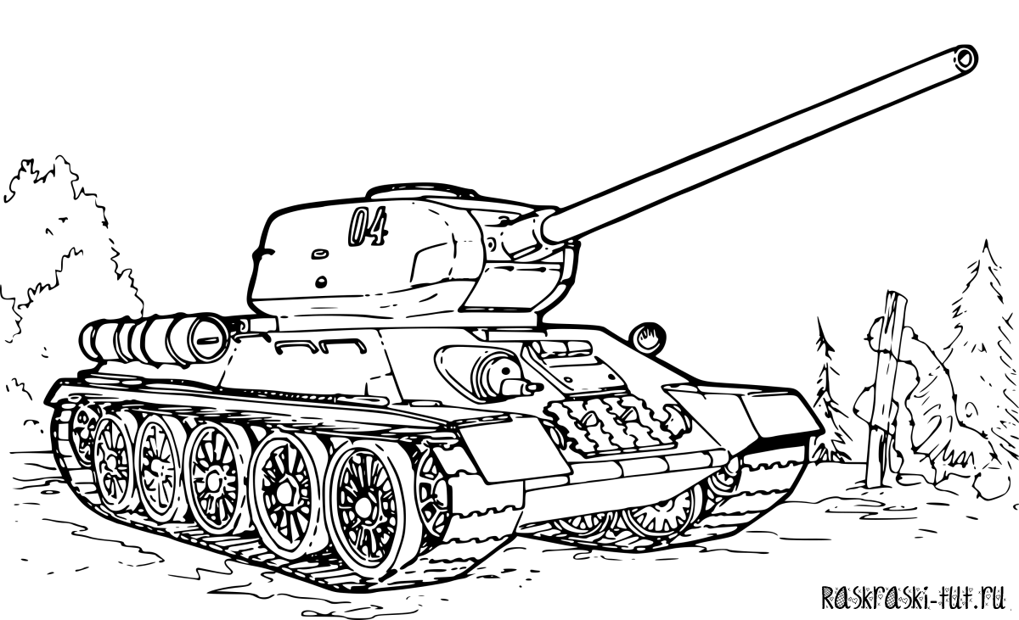

Рис.2

